Name
Course
Tutor
Date
Week 1 Discussion 3
Interpretation of statistical data is important in making accurate conclusions. Statistics has been significantly used in explaining key concepts and thus ensuring that the interpretation is accurate allows for better decisions. Misleading graphs have significantly been used in the media when trying to manipulate figures in order to advance a specific narrative. The misleading graph that will be discussed in this case is focuses on unemployment rate under the Obama administration.
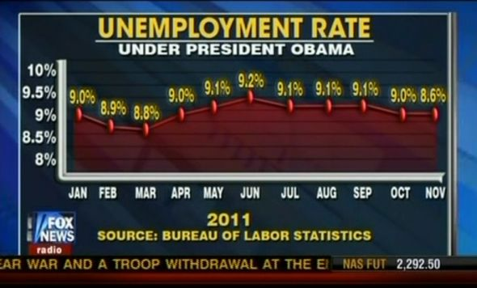
Why the graph is inaccurate
The representation of information on the graph is very misleading and it is aimed to confuse the audience in advancing a certain aspects regarding the level of unemployment under the Obama administration. The values that are highlighted within the graph are very different from the values on the y-axis, which makes it difficult to have an accurate interpretation based on the guiding values that have been included (Hasting, 2015). Another critical aspect regarding the graph which is misleading is that the y-axis does not begin from zero hence it is very difficult to make any meaningful information from the graph. The scale that has been considered on the y-axis is 0.1 that is very small making it difficult to make a correct estimation, which would be important in making predictions from the graph.
What could have been done to make the graph accurate?
Ensuring that the graph represents important information that can be relied upon in making decision requires critical focus on rescaling of the y-axis, ensure that it begins from zero, and avoid small interval such as 0.1 since it would be easier to interpret and make prediction based on whole numbers, which represent the percentage unemployment rate. The values within the graph should also be realigned to ensure that they provide important information, which can form the basis of accurate understanding on the development of percentage rate of unemployment under President Obama (Hasting, 2015).
References
Link
https://www.futurescienceleaders.com/mariecurious/2013/10/09/misleading-graphs-2/
Hastings, K. J. (2015). Probability and statistics. Reading, Mass: Addison-Wesley.

